
Via Michelangelo Buonarroti, 52/B - 20093 Cologno M.se (Mi)

X- RAY MOBILE SHIELDS

INSTALLATION AND INSTRUCTION


REV.01/2013

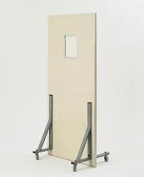
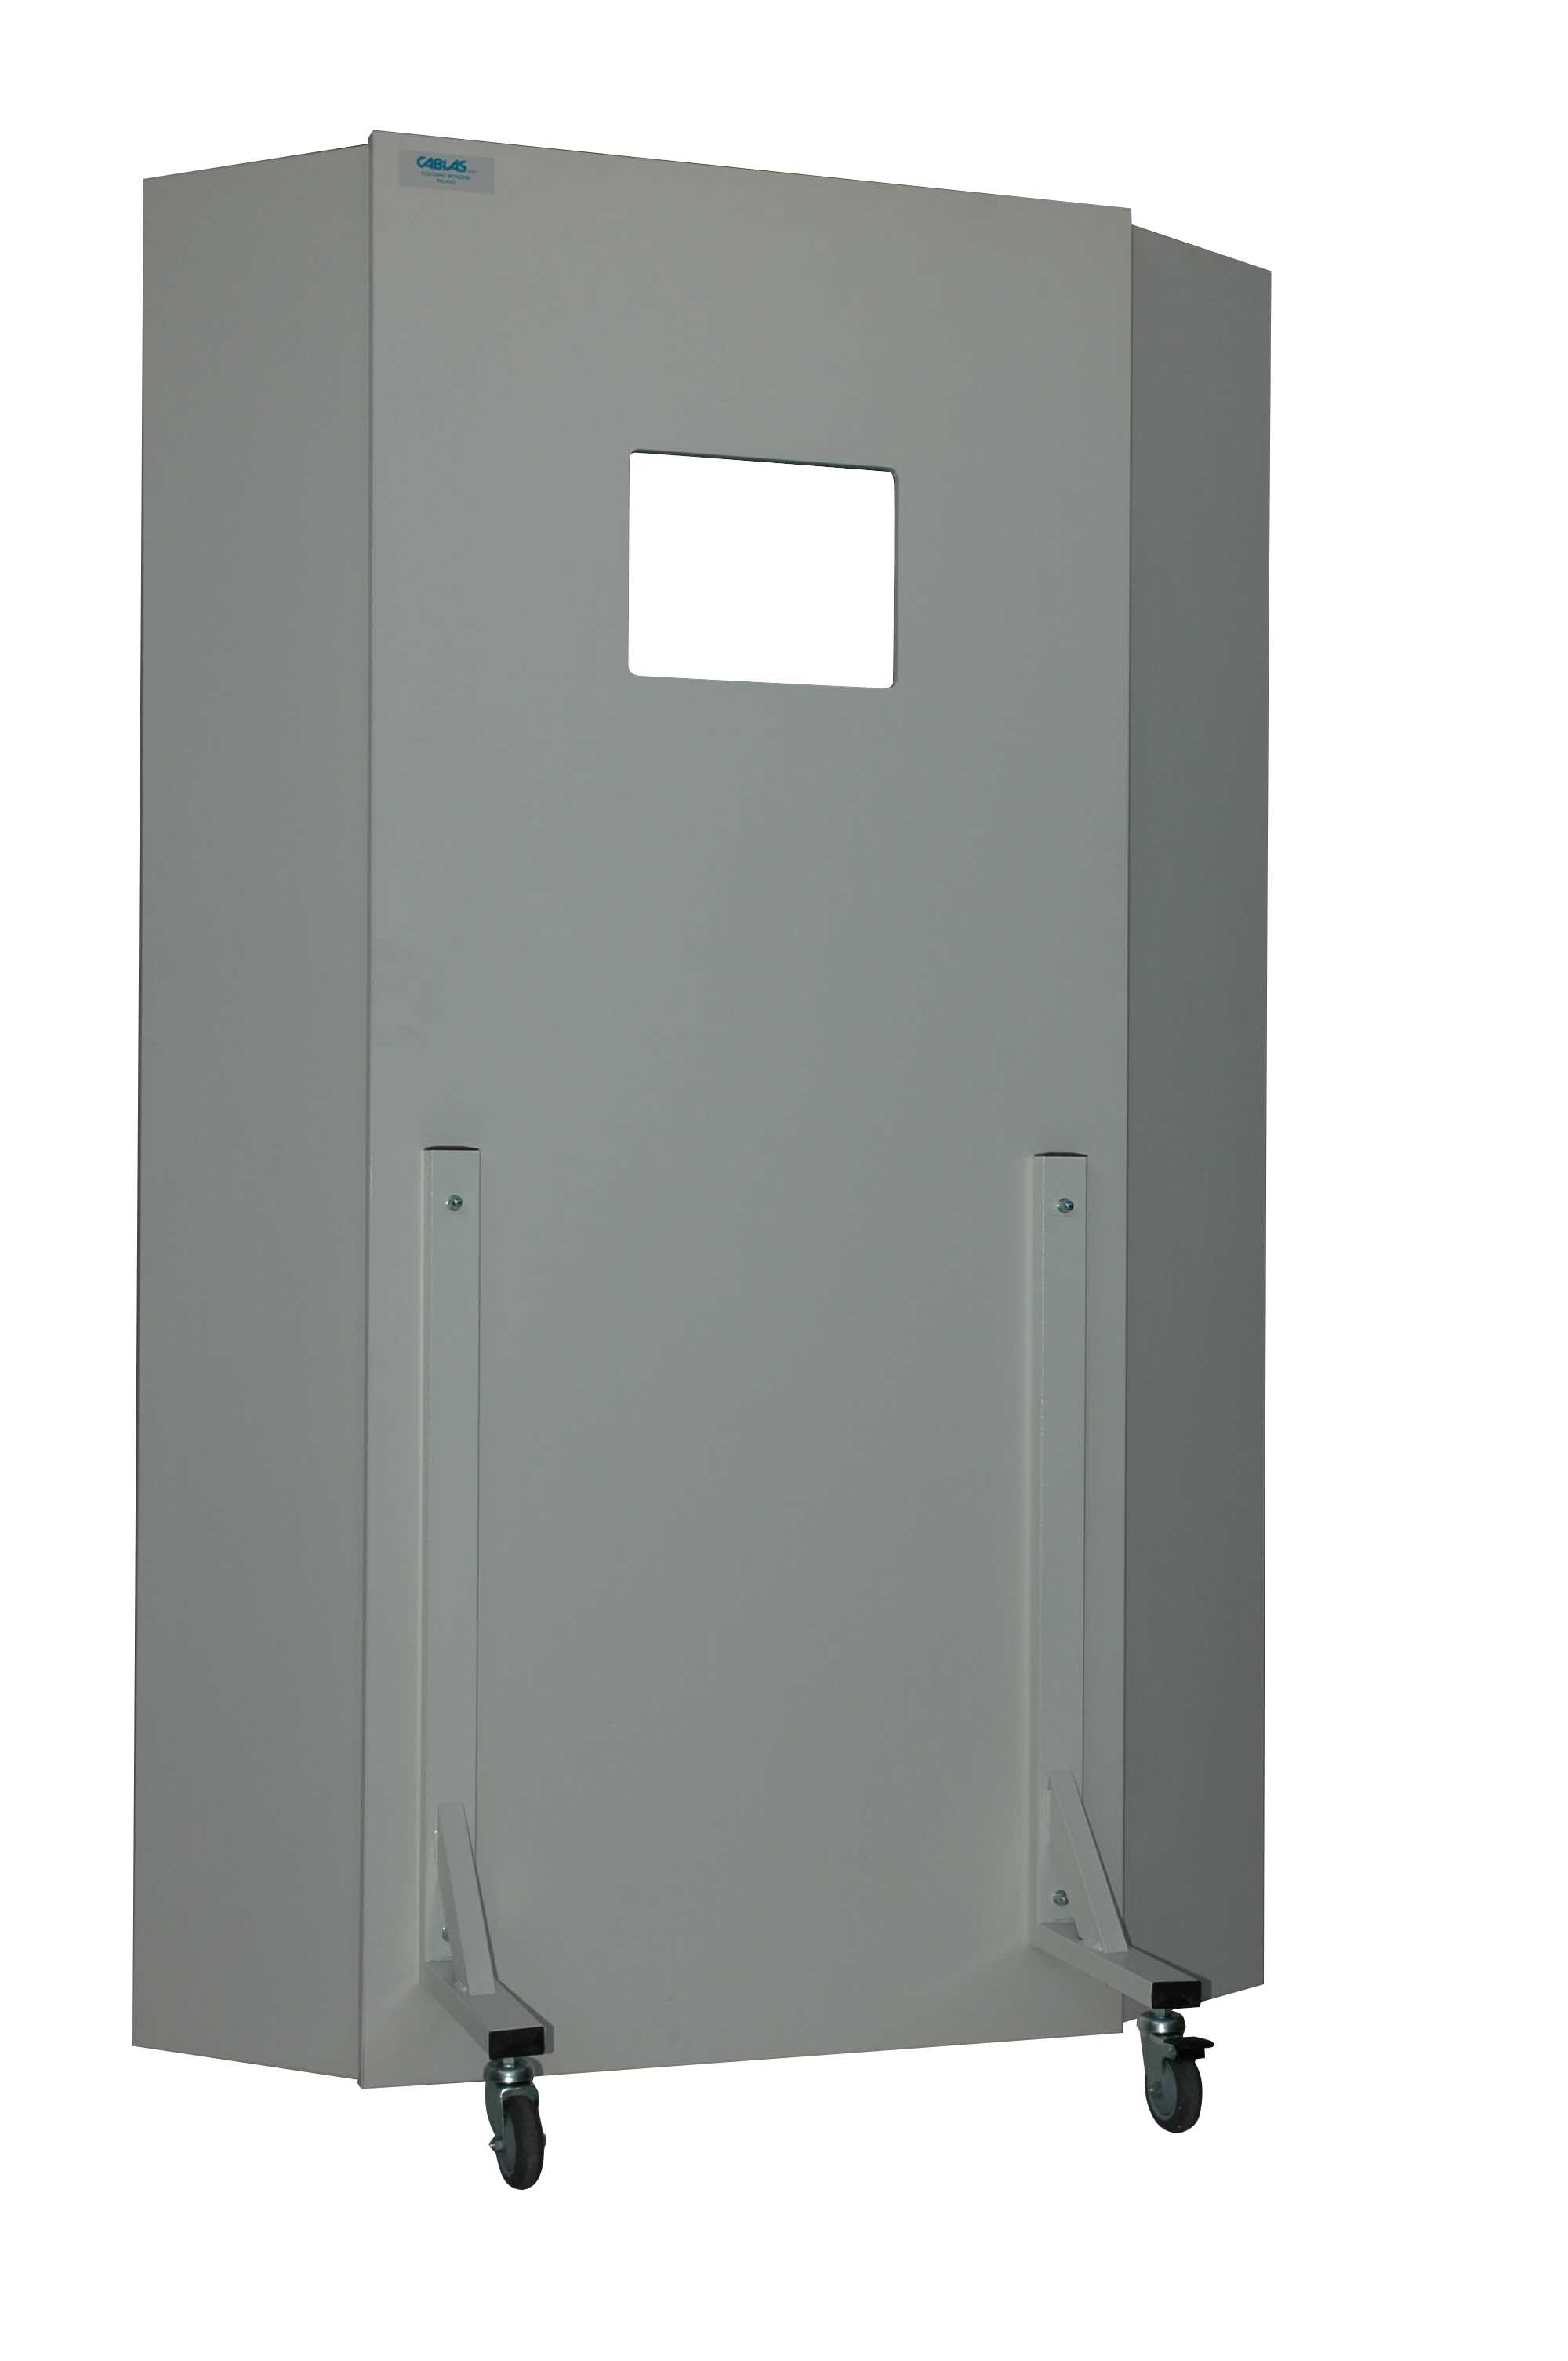

CODE | DIMENSION | DOOR | VISUAL GLASS | WEIGHT
P-PM-01 | CM 80 X 190H | 1 | CM 24 X 30 | KG 73
P-PM-02 | CM 80 X 190H | 1 | CM 30 X 40 | KG 75
P-PM-03 | CM 30+80+30 X 190H | 3 | CM 24 X 30 | KG 105
P-PM-04 | CM 30+80+30 X 190H | 3 | CM 30 X 40 | KG 107

Via Michelangelo Buonarroti, 52/B - 20093 Cologno M.se (Mi)

1)
After placing the central panel on a suitable surface, place the glass ANTIX (B) into place and lock it with the frame (C) using its screws.
2)
Positioning, respecting the references listed on the panels, the two side panels (only in the case of walls with three doors) and secure using wood screws.
3)
Apply the support legs (E), as in the drawing, and secure the center panel using threaded rods (F) with the washers and nuts.

ATTENZIONE
The central panel weighs about 70 Kg. It is recommended that at least two people to handle it.

