 | Via Michelangelo Buonarroti, 52  20093 Cologno Monzese (MI)  Tel. (02) 253.80.88 r.a.  Telefax (02) 27300644  www.cablas.com  cablas@cablas.com

TECHNICAL DATA SHEET
O-OC-131  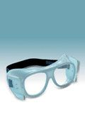  O-OC-132  PALOMBARO MODEL  - Frontal and side protection;  - Wearable over prescription spectacles;  O-OC-131  FRONT PROTECTION:  EQ PB MM 0.75  SIDE  PROTECTION :  EQ PB MM 0.35  O-OC-132  FRONT PROTECTION  EQ PB MM 0.75  SIDE  PROTECTION :  EQ PB MM 0.10 | O-OC-120  PALOMBARO MODEL  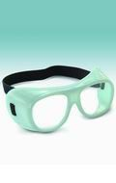  - Frontal protection;  - Wearable over prescription spectacles;  FRONT PROTECTION:  EQ PB MM 1 | 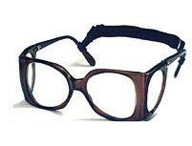  O-OC-112  - Frontal and side protection;  - Frame made of plastic material;  FRONT PROTECTION:  EQ PB MM 0.75  SIDE  PROTECTION:  EQ PB MM 0.50 | O-OC-115  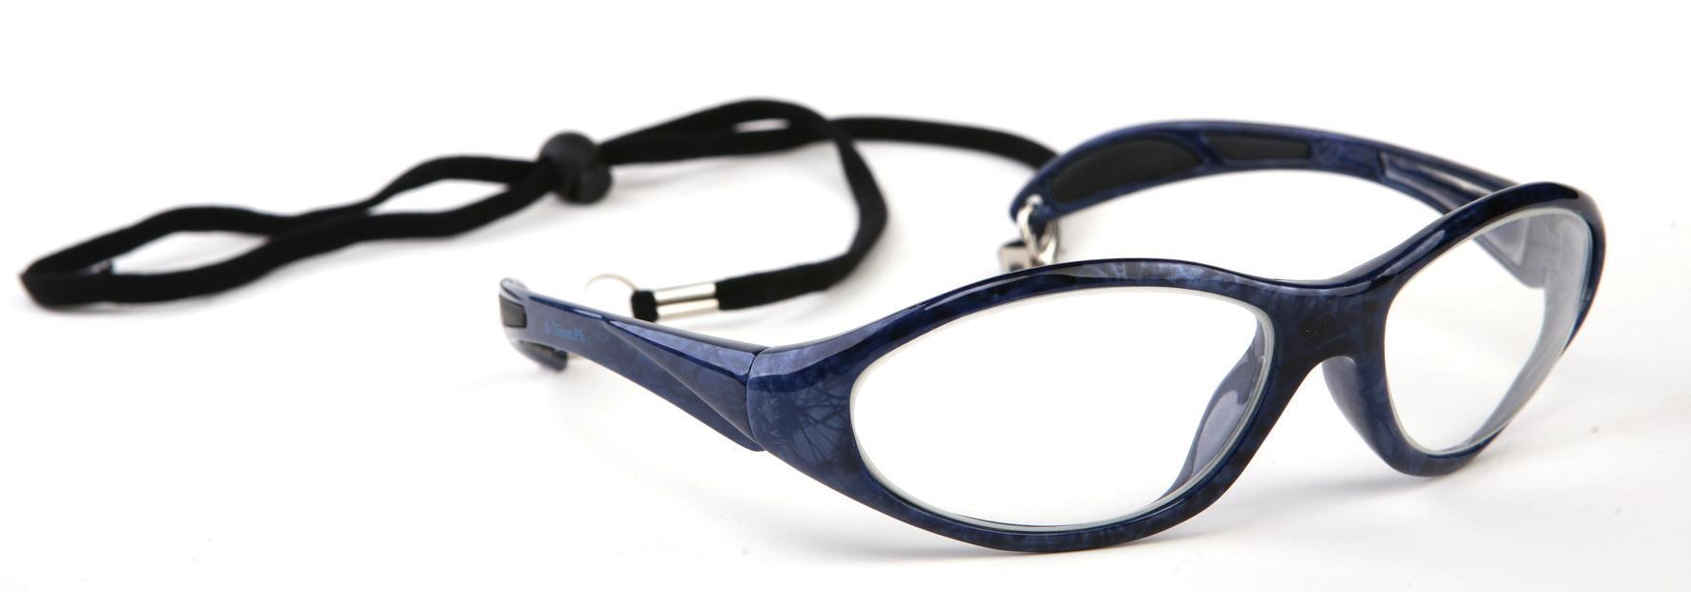  - Frontal protection;  - Frame made of plastic material;  FRONT PROTECTION:  EQ PB MM 0.75
ANTIX GOOGLES

